**Testing and Evaluation for Smart Vitals System**

* If the user plugs the system, OLED screen shows the device being tuned on.

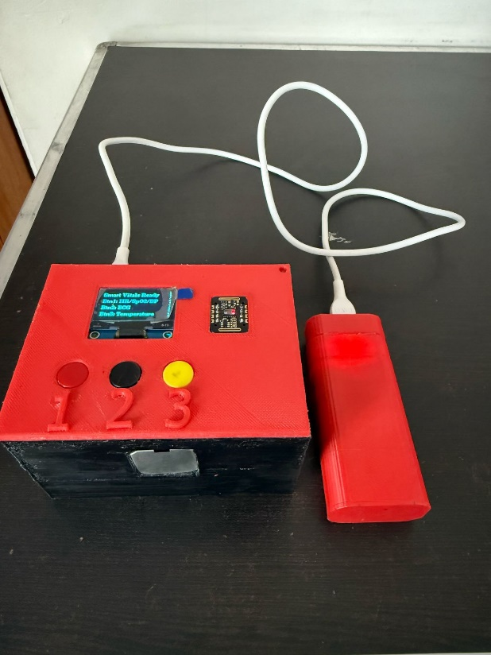

* If the user presses button1, it activates the MAX30102 sensor.

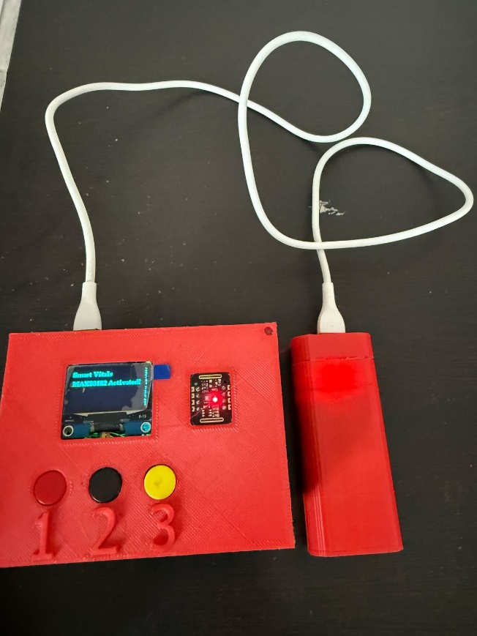

* The OLED should display message “Please place your finger on the sensor.” When finger is not placed on the senor.

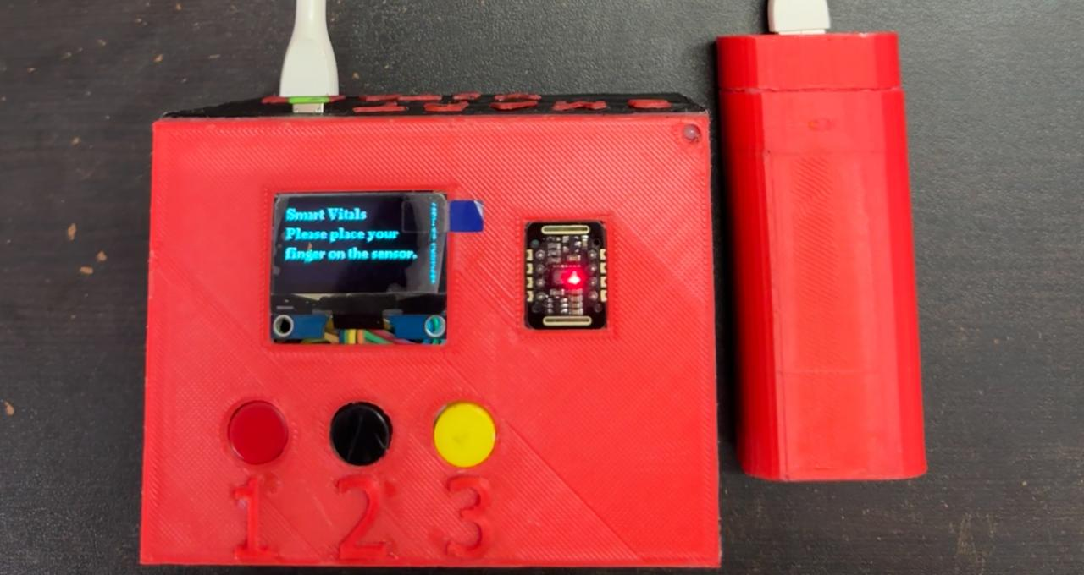

* The sensor should start taking readings when user places their finger on the sensor.

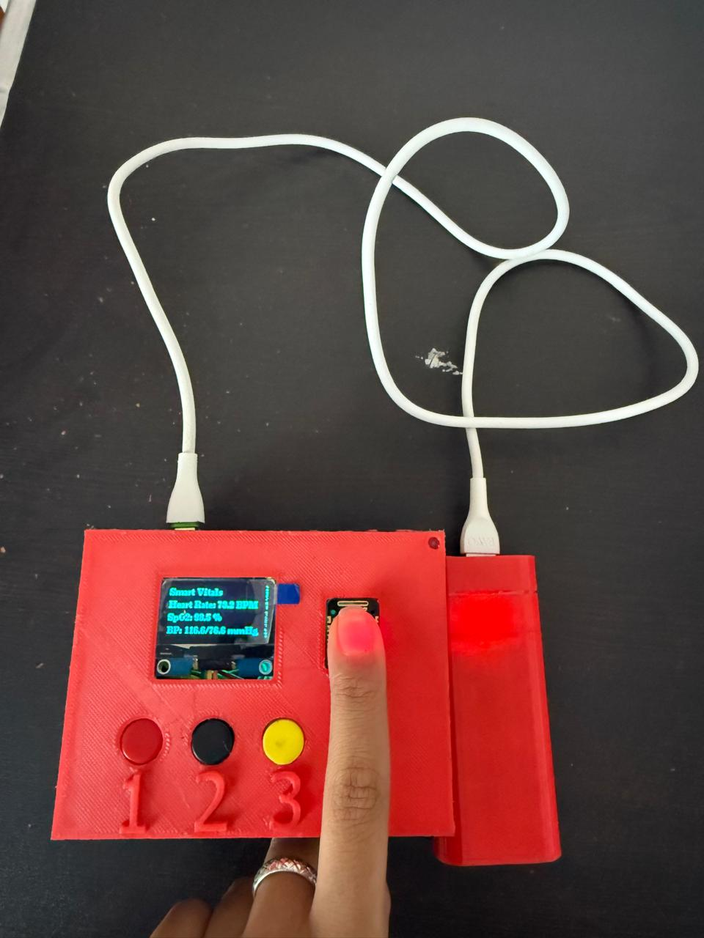

* If the user presses button 1 again, it deactivates the MAX30102 sensor.

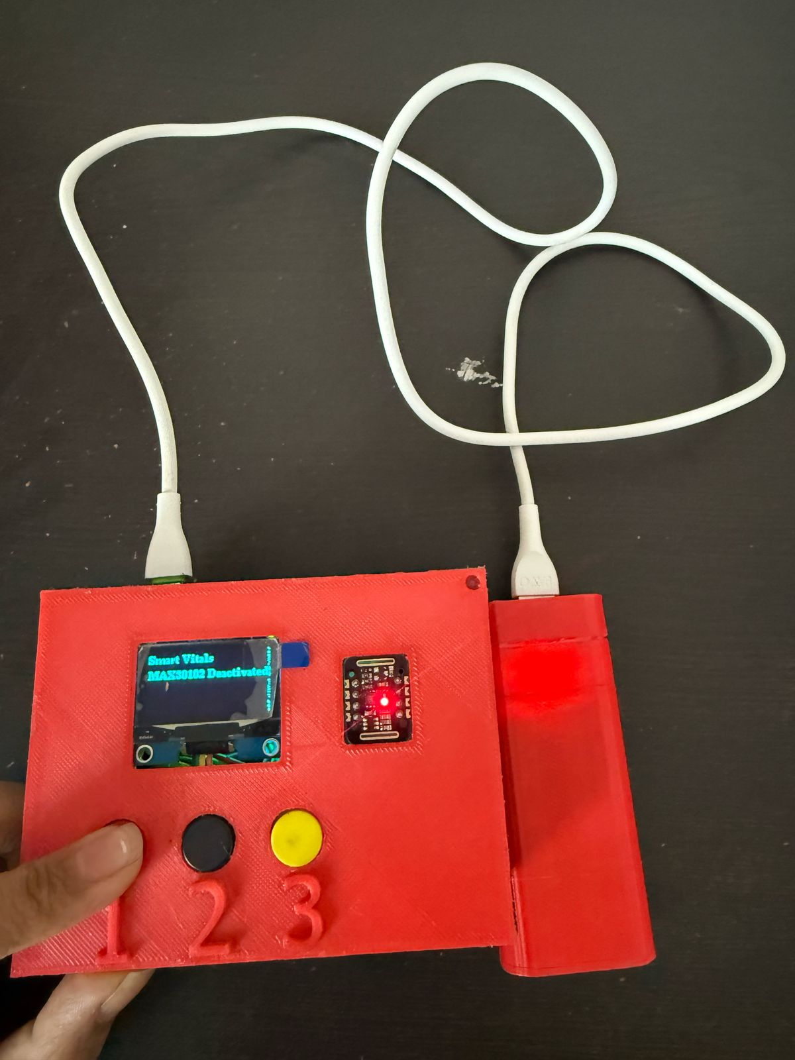

* If the user presses button2, it activates the ECG sensor.

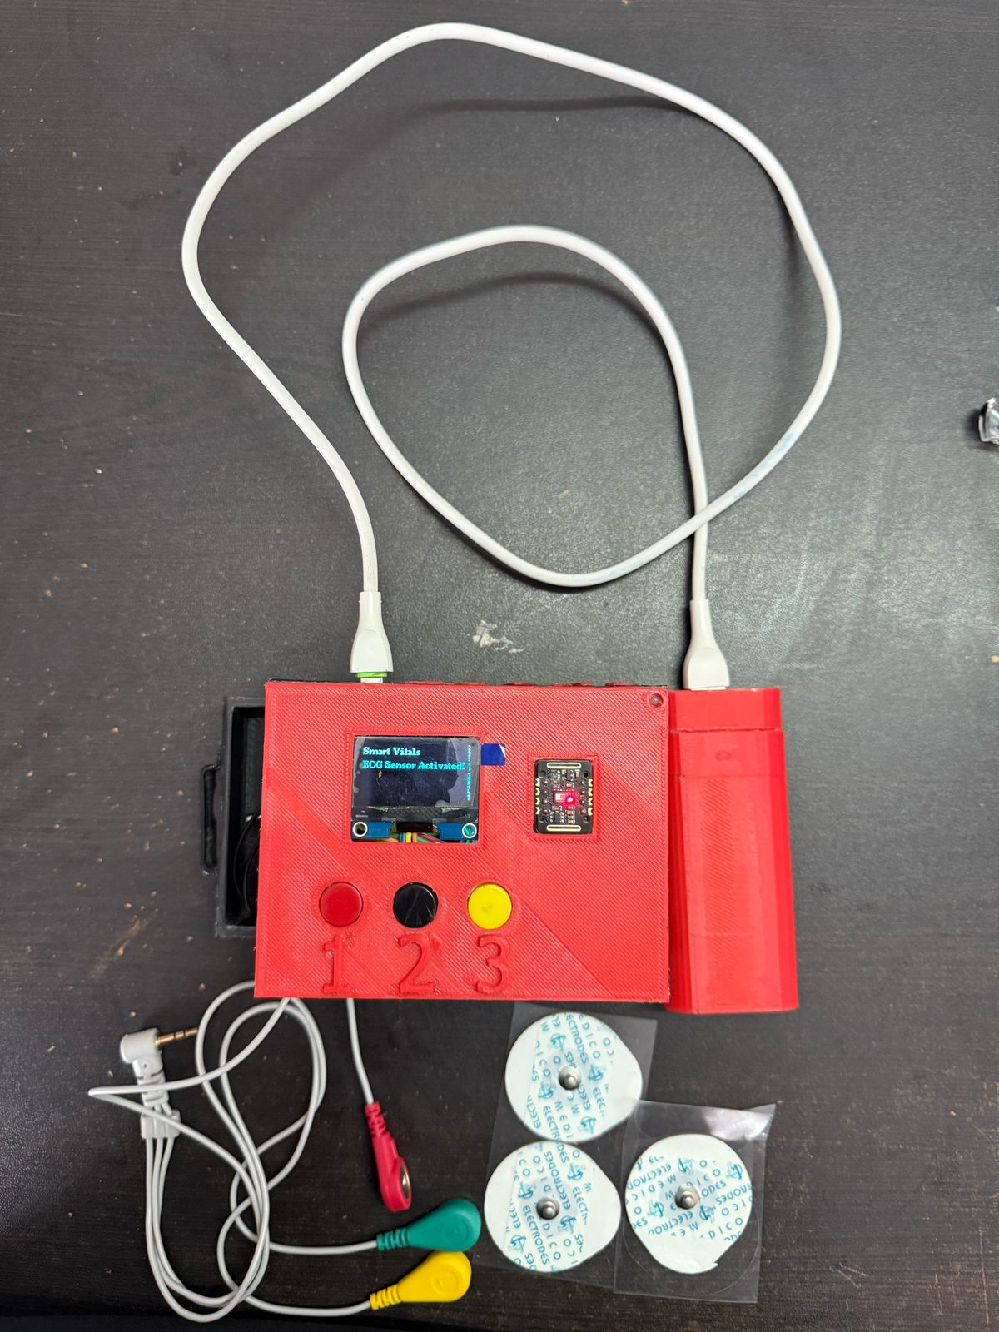

* If the user plugs in the cable for patch, an ECG waveform is seen.

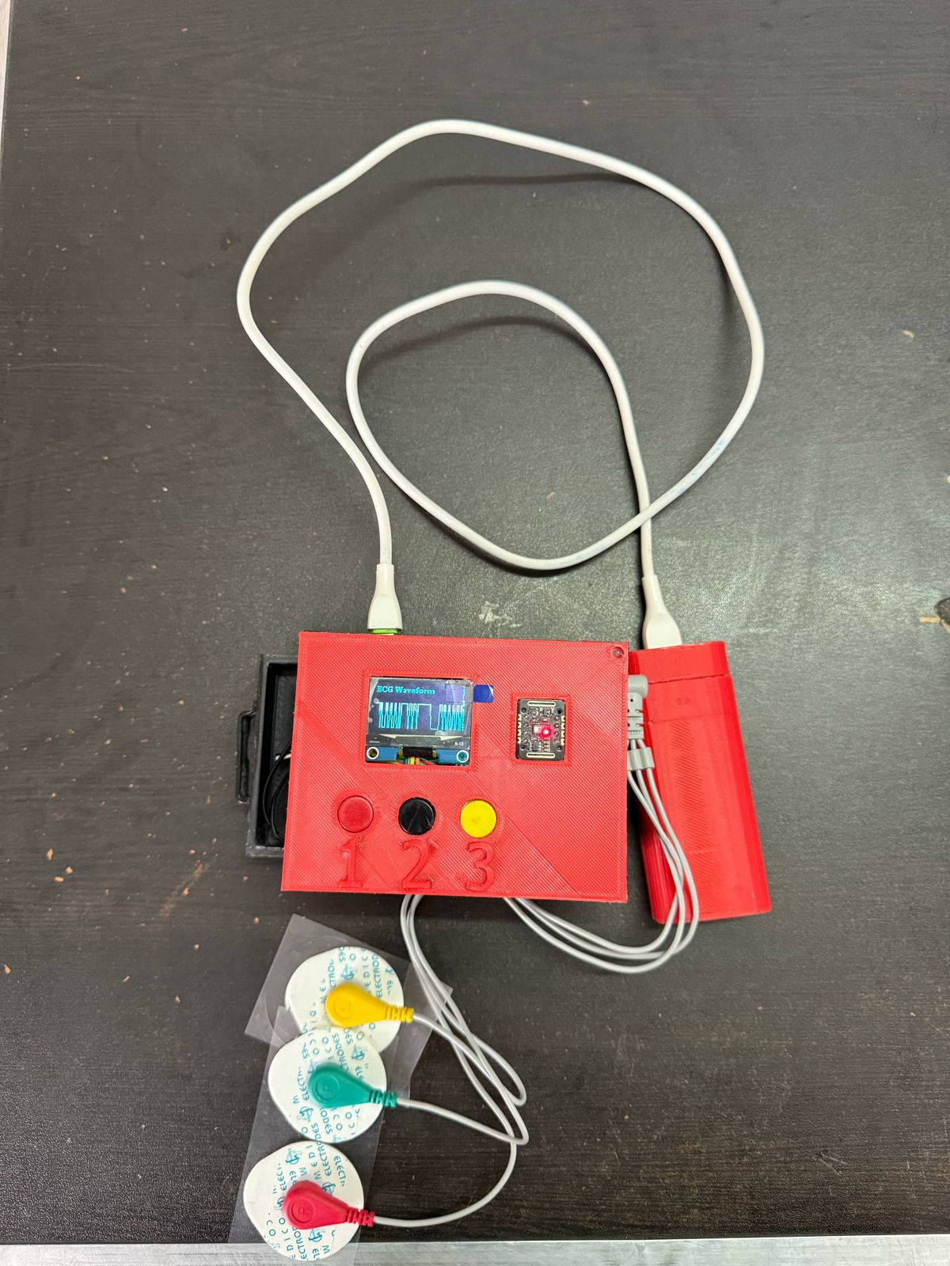

* If the user presses button 2 again, it deactivates the ECG sensor.

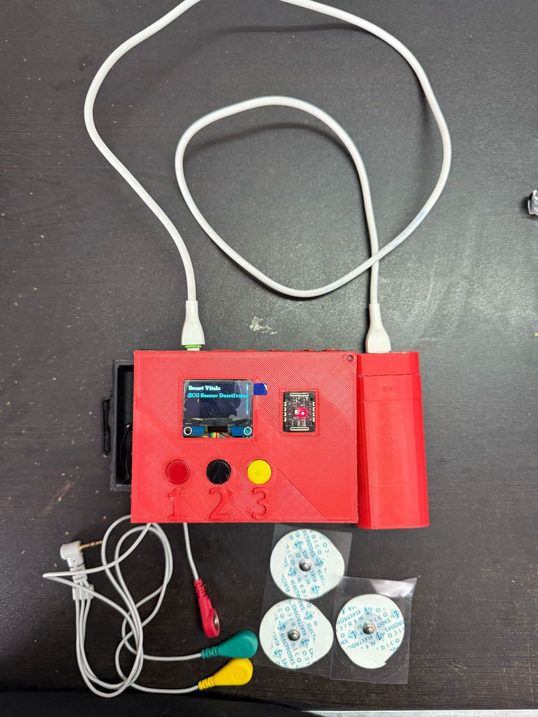

* If the user presses button3, it activates the Temperature sensor.

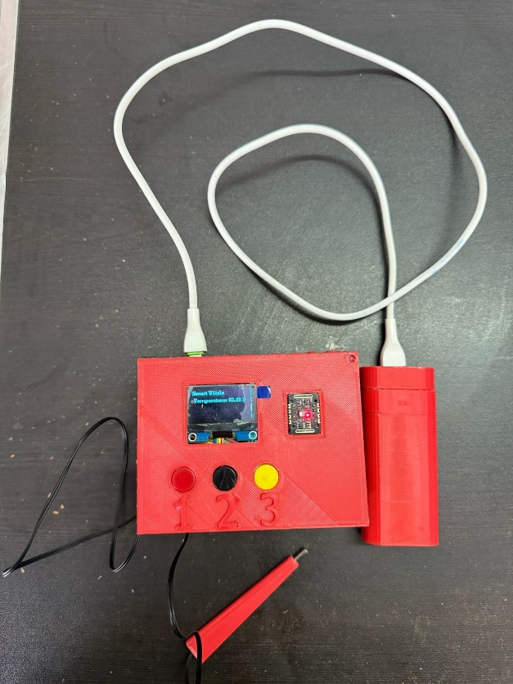

* If the user unplugs the power to the system, the device turns off.

